CuraAid User Manual
CuraAid is a centralized healthcare portal. Patients get initial (non-diagnostic) guidance, book a doctor, consult by text / audio / video, receive e-prescriptions, keep records, and order medicines. Doctors verify themselves, set availability, approve bookings, consult online, and write prescriptions.
This manual is for patients and doctors. Platform administrators should use ADMIN_MANUAL.md.

1. How to run the project (local)
Open two terminals.
Backend (Laravel)
cd C:\Users\root\Downloads\FYP\backend
php artisan serve --host=127.0.0.1 --port=8000
Frontend (React)
cd C:\Users\root\Downloads\FYP\Frontend\my-react-app
npm start
Then open http://localhost:3000. The API runs at http://127.0.0.1:8000/api.

2. Demo accounts
Role | Email | Password
Patient | patient1@test.com | secret123
Doctor (verified cardiologist) | doctor1@test.com | secret123
Extra doctors (same password) | doctor2@test.com … doctor7@test.com | secret123

Admin credentials are in the Admin Manual.

3. Home page
Open http://localhost:3000. The banner rotates between Initial Guidance, Pharmacy, and the main CuraAid message.
Figure: CuraAid home page

From the top bar you can open:
- Home
- About Us
- Pharmacy
- Doctor Finder (Initial Guidance chatbot)
- Feedback
- Light / Dark theme
- Profile (login / dashboard)
Use Start Initial Guidance for the chatbot, or Visit Pharmacy to shop.

4. Create an account
- Open Login from the profile icon (or go to /login).
- Click Create Account.
- Choose Patient or Doctor on Role Selection.
- Fill name, email, phone, and password (minimum 6 characters).
- Doctors are then asked to upload verification documents (PMDC number, license, CNIC, qualifications). An admin must approve the profile before the doctor appears in public search.
Google sign-in is available on the login screen if your Google client ID is configured.

5. Login
Go to /login. Enter email and password, then Login.
Figure: Patient login
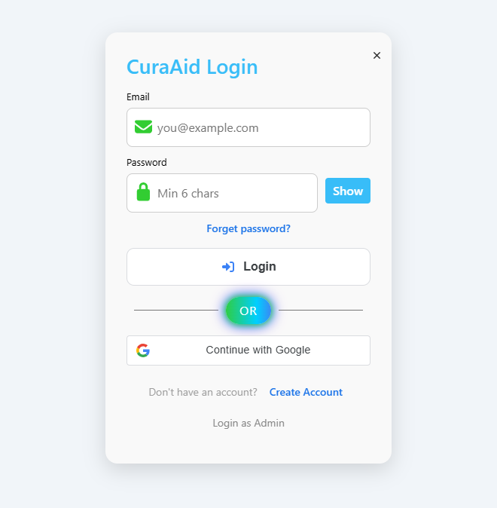
After a successful login you land on Dashboard.
Forgot password sends a reset link to the Laravel log file (backend/storage/logs/laravel.log) in this demo setup — mail is not sent to a real inbox.

6. Patient dashboard
Figure: Patient dashboard
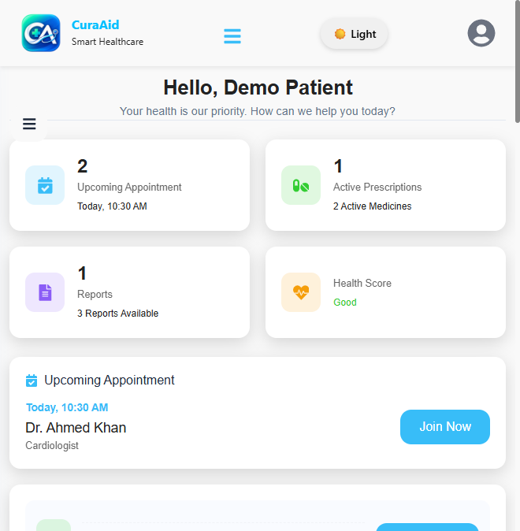
You will see:
- Upcoming appointments, active prescriptions, reports, and a simple health score
- The next appointment with Join Now (opens Virtual Clinic)
- A short assistant on the right for common questions
- My Consultations (Ongoing / Completed)
Open the hamburger menu (☰) for:
Menu item | What it does
Dashboard | Overview
Consultations | Case list
Appointments | Book, track, cancel / reschedule
Prescriptions | E-prescriptions from completed visits
Medical Records | Notes, diagnosis, reports, revisit
Profile Settings | Name, photo, password, 2FA, location

7. Initial Guidance chatbot (Doctor Finder)
This is not a diagnosis tool. It ranks suitable verified doctors by specialty, rating, experience, and availability.
Open Doctor Finder in the header, or go to /ai-health-guide.
Figure: Initial Guidance specialties
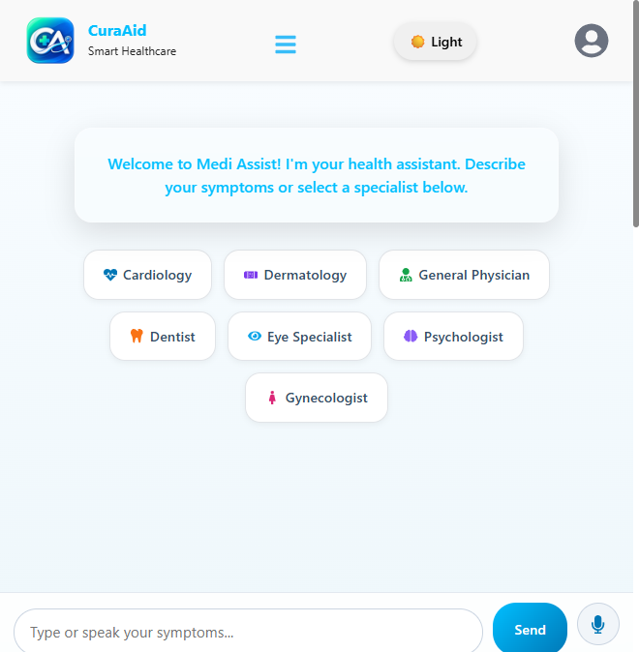
How to use
- Type symptoms (for example: “chest pain and shortness of breath”) or tap a specialty chip such as Cardiology.
- You can also use the microphone to speak.
- The assistant lists matching doctors. Online doctors appear first.
Figure: Matched doctors with Consult, Call, Book
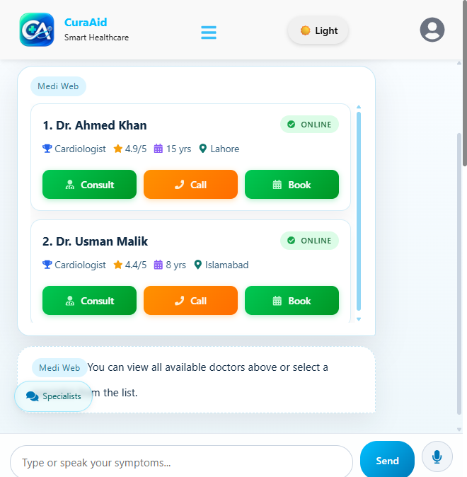
On each doctor card:
- Consult — start a text consultation in Virtual Clinic
- Call — start an audio consultation
- Book — request an appointment (pending doctor approval)

8. Book an appointment
From Appointments click Book appointment, or use Book on a doctor card.
Figure: Appointments page
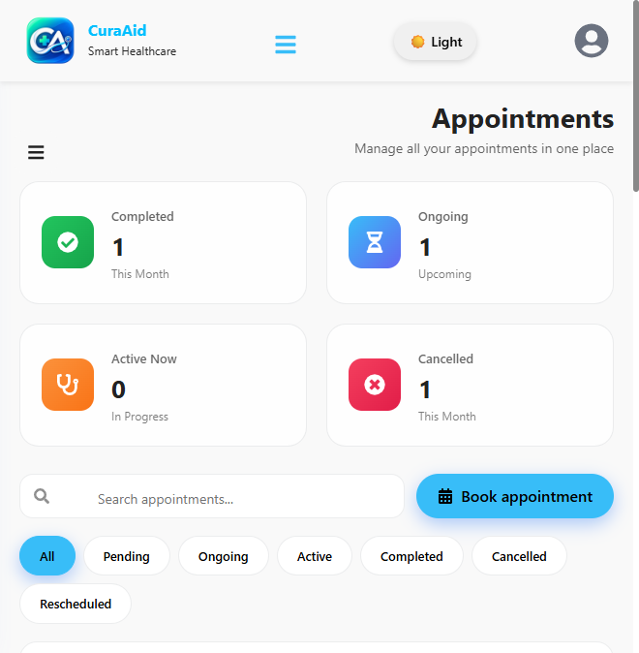
- Select a doctor.
Figure: Select a doctor
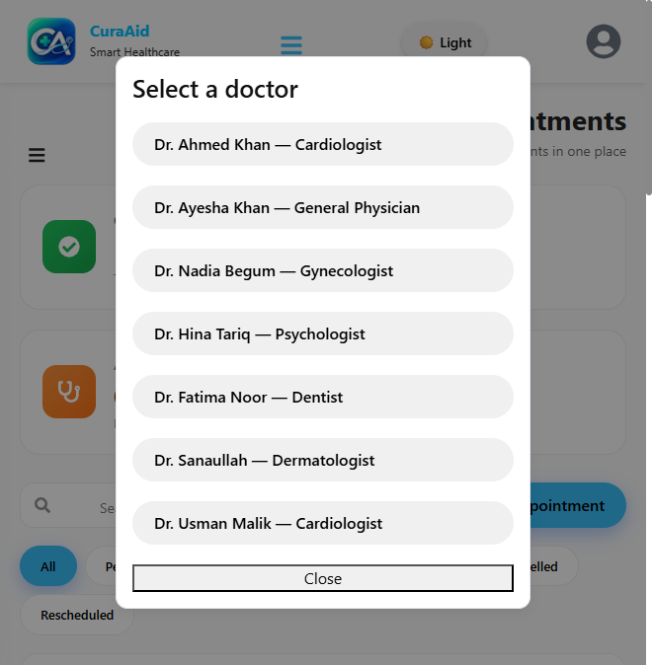
- Choose date, time, and consultation type:
- Video
- Audio
- Text / Chat
- Physical visit
Figure: Book appointment form
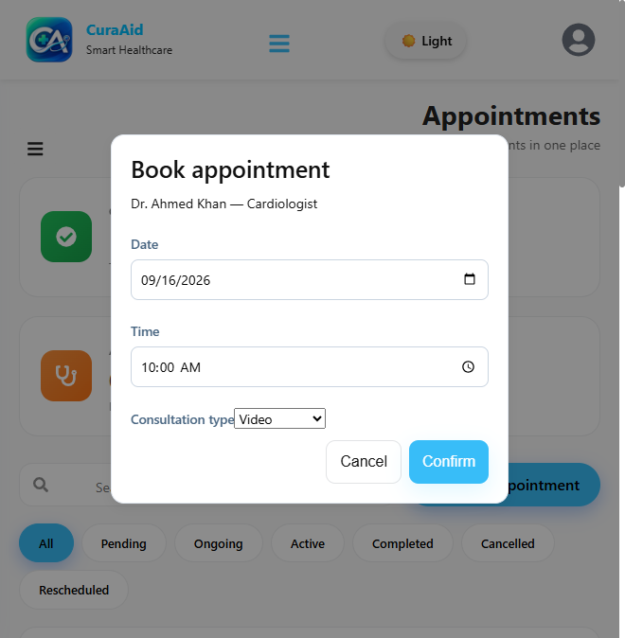
- Click Confirm. The booking is saved as Pending. The doctor must Approve or Reject it. You will see the status under the Pending / Ongoing / Completed tabs.
You can search, cancel, or request a reschedule from the appointment card. The doctor must accept a reschedule.

9. Consultations and Virtual Clinic
Consultations lists every case (ongoing, active, completed, cancelled).
Figure: Consultations
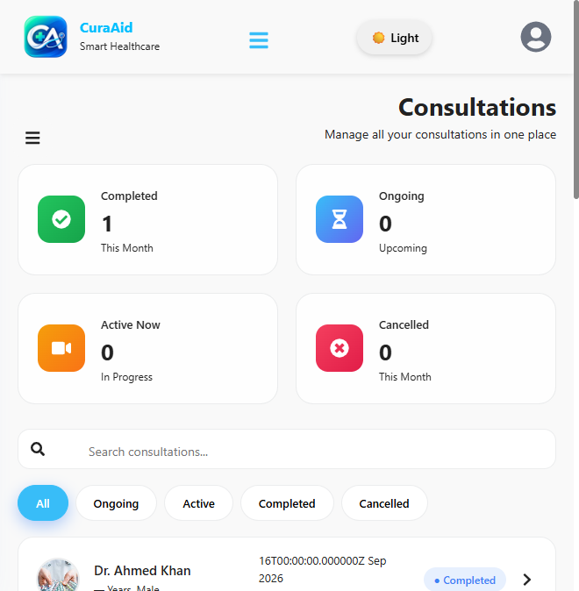
Join Now on the dashboard, or open /clinic, to enter Virtual Clinic.
Figure: Virtual Clinic
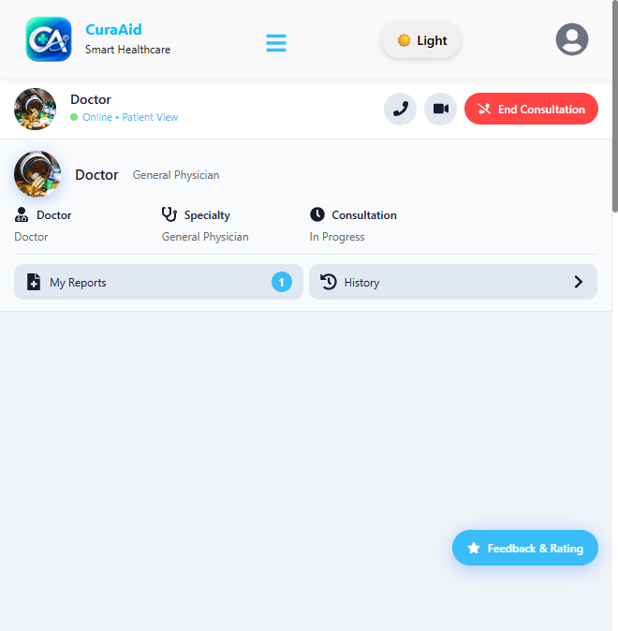
Inside the clinic you can:
- Chat with the doctor
- Start audio or video (both people must be in the same consultation)
- Attach lab reports and share them with the doctor
- End the consultation
- Leave Feedback & Rating when finished
Both sides need a modern browser and microphone/camera permission for calls. The demo uses a public STUN server (no TURN), so some networks may block video.

10. Prescriptions
After a doctor completes a visit with medicines, they appear under Prescriptions.
Figure: My Prescriptions
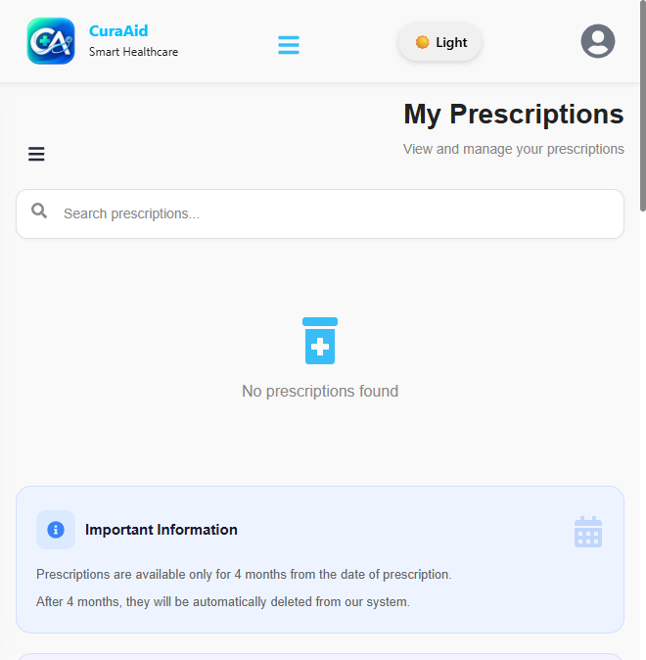
Prescriptions stay in the system for 4 months, then they are removed. You can search by medicine or doctor name.
Use Pharmacy → Use my latest e-prescription to add those medicines to the cart automatically.

11. Medical records
Open Medical Records (/records).
Figure: Medical records
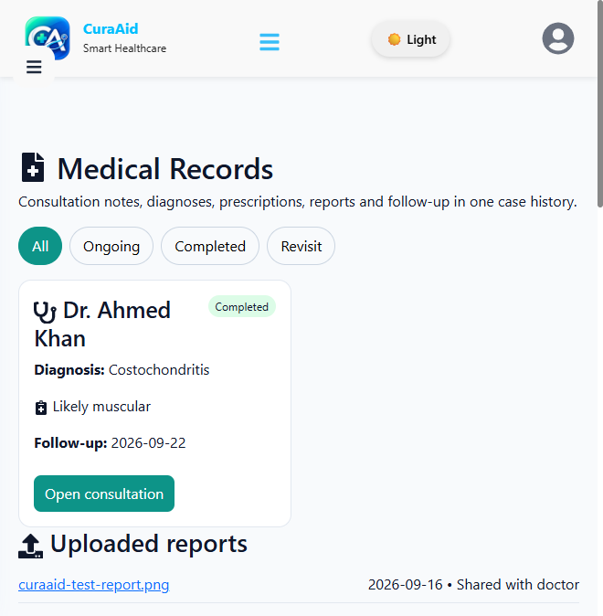
Filter cases:
- All
- Ongoing
- Completed
- Revisit (doctor recommended a physical follow-up)
Each card shows diagnosis, notes, follow-up date, and Open consultation. Uploaded reports appear at the bottom. Files shared with the doctor are marked accordingly.

12. Pharmacy, cart, and checkout
Open Pharmacy. Search, filter by category / type / illness / brand / price, then click Add to Cart.
Figure: Pharmacy catalogue
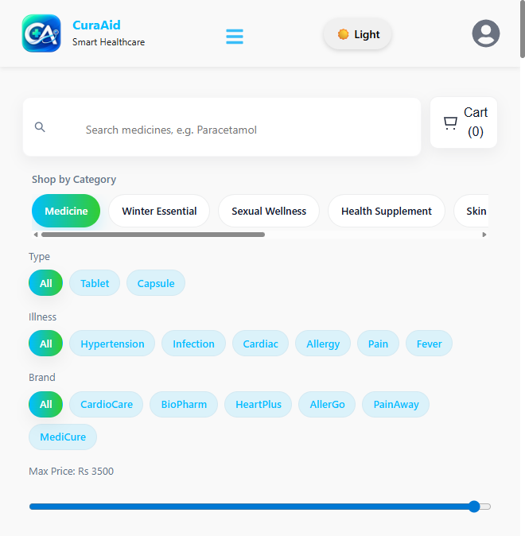
Add to Cart is for patients and guests. The cart stays in this browser until you checkout or clear it (refresh does not empty it).
Two ways medicines enter the cart
- Click Add to Cart on a product card.
- Upload a prescription image/PDF, or click Use my latest e-prescription. The system matches names against stock (OCR in the browser + catalogue).
Figure: Upload prescription
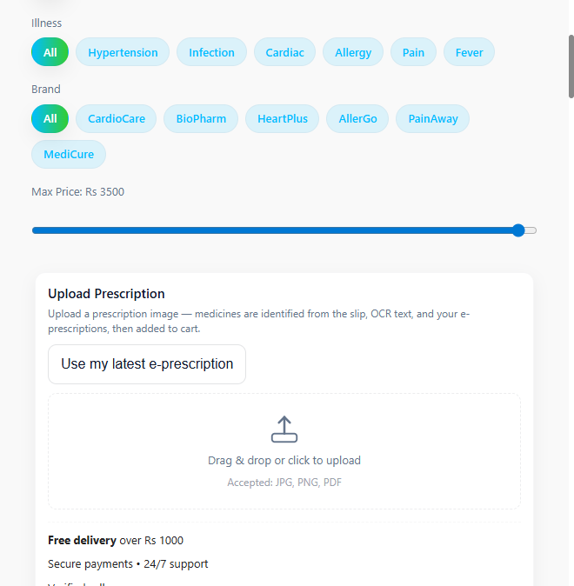
Then:
- Open Cart.
- Change quantity or remove items.
- Click Checkout.
- Enter name, phone, and delivery address.
- Choose Cash on Delivery or Card.
Card checkout is recorded as paid in the database for the demo. There is no live Stripe / PayFast gateway.
If a medicine on a slip is not in stock, it is listed as unavailable and is not added to the cart.

13. Profile settings
Figure: Profile settings
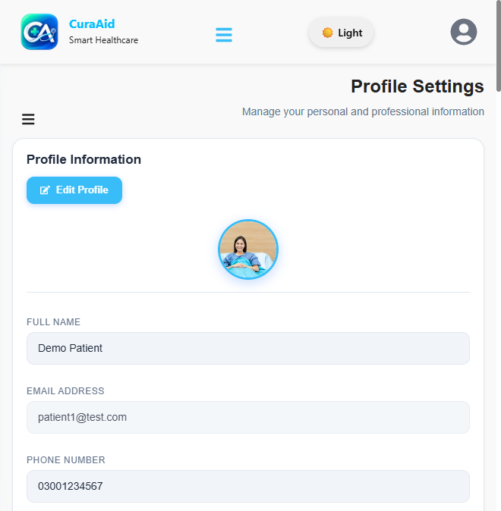
You can:
- Edit name, phone, gender, date of birth, blood group
- Change avatar
- Change password
- Turn two-factor authentication on or off
- Set language, region, and map address

14. Feedback and About
- Feedback (/feedback) — send a message to the platform. Logged-in name and email are filled for you.
- About Us (/about) — mission, team, and links into guidance / pharmacy.
Figure: About CuraAid
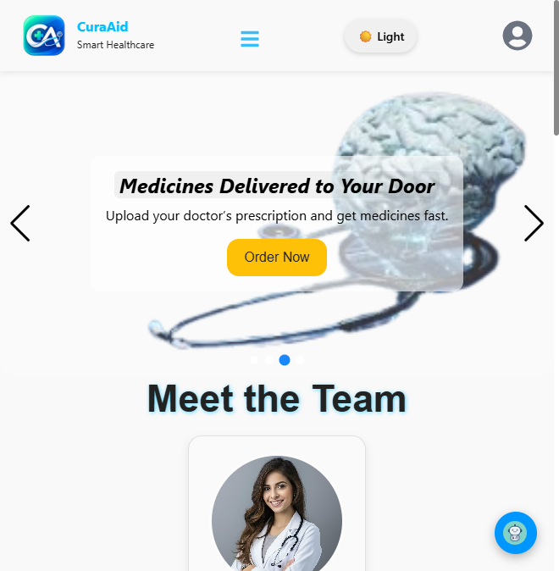
You may also rate a doctor after a consultation from Virtual Clinic (Feedback & Rating).

15. Doctor workflow (if you registered as a doctor)
Log in with a doctor account (for example doctor1@test.com). The sidebar adds extra items.

15.1 Dashboard
Shows today’s consultations, upcoming appointments, patient count, rating, schedule, and weekly analytics.

15.2 Availability
Availability sets weekly slots and max appointments per day. When the daily cap is reached, new patient bookings for that date are rejected.

15.3 Appointments
Pending requests from patients appear here. Open a request and:
- Approve — status becomes scheduled
- Reject — optional reason; patient sees it as not approved
You can also handle reschedule approve / reject.

15.4 Consultations / Virtual Clinic
Start the visit, chat, audio/video, write notes, diagnosis, treatment, and an e-prescription (medicine name, dosage, frequency, duration). You may recommend a physical revisit. Completing the visit moves the case to Completed and creates the patient’s prescription record.

15.5 Patients, prescriptions, medical records
Your patient list is built from appointment and consultation history. Prescriptions and records match what the patient sees for those visits.

15.6 New doctor verification
Until an admin approves your documents on Documents, you will not appear in the public doctor list or chatbot ranking.

16. Honest limits (demo)
- Not a diagnosis. The chatbot only suggests specialists.
- Card payment is simulated (order stored as paid).
- Video/audio needs both users online in the same consultation; some NATs block WebRTC.
- OCR loads Tesseract.js from a CDN the first time you upload a prescription image.
- Emergency: the UI mentions 24/7 help — in this FYP build that is informational, not a live ambulance dispatch.

17. Quick reference — patient URLs
Page | URL
Home | /
Login | /login
Signup | /signup
Initial Guidance | /ai-health-guide
Pharmacy | /pharmacy
Dashboard | /dashboard
Appointments | /appointments
Consultations | /consultations
Virtual Clinic | /clinic
Prescriptions | /prescriptions
Medical records | /records
Settings | /settings
Feedback | /feedback

